Wildcard SAN certificate
# Source: AI Source: Provided by: [Data Path: Persons Table -> ID Column: 1, Name_En Column: Motasem Essam] -> From: [ChatGPT] on [1/18/2026]
A Wildcard SAN certificate is a type of SSL/TLS certificate that combines Wildcard functionality with Subject Alternative Names (SANs), allowing you to secure multiple domains and their subdomains with a single certificate.

🔐 What Wildcard SAN Means
# Source: AI Source: Provided by: [Data Path: Persons Table -> ID Column: 1, Name_En Column: Motasem Essam] -> From: [ChatGPT] on [1/18/2026]
- Wildcard (*) → covers all first-level subdomains of a domain
- SAN (Subject Alternative Name) → allows multiple domains or wildcards in one certificate
- Provides flexibility for multi-domain, multi-subdomain setups
Example SAN List
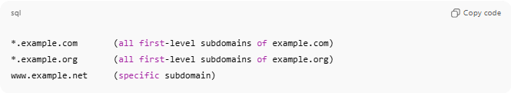
*.example.com (all first-level subdomains of example.com)
*.example.org (all first-level subdomains of example.org)
www.example.net (specific subdomain)
This single certificate secures multiple domains and their subdomains.

🛠️ How It Works
# Source: AI Source: Provided by: [Data Path: Persons Table -> ID Column: 1, Name_En Column: Motasem Essam] -> From: [ChatGPT] on [1/18/2026]
- Certificate is issued listing all SAN entries, including wildcards
- Browsers match the requested hostname against the SAN entries
- If a match is found → HTTPS connection is trusted
- Encryption works the same as a standard SSL/TLS certificate

📍 Where Wildcard SAN Certificates Are Used
# Source: AI Source: Provided by: [Data Path: Persons Table -> ID Column: 1, Name_En Column: Motasem Essam] -> From: [ChatGPT] on [1/18/2026]
- Enterprises managing multiple domains and subdomains
- SaaS platforms with complex multi-tenant architecture
- Cloud and microservices environments
- Large e-commerce or banking platforms

✅ Advantages
# Source: AI Source: Provided by: [Data Path: Persons Table -> ID Column: 1, Name_En Column: Motasem Essam] -> From: [ChatGPT] on [1/18/2026]
- One certificate covers many domains and subdomains
- Reduces management overhead
- Cost-effective for complex setups
- Same strong encryption as DV/OV/EV certificates

⚠️ Limitations
# Source: AI Source: Provided by: [Data Path: Persons Table -> ID Column: 1, Name_En Column: Motasem Essam] -> From: [ChatGPT] on [1/18/2026]
- Private key compromise affects all domains/subdomains
- More expensive than single-domain certificates
- Can become complex if many SAN entries are added
- EV Wildcard is not allowed (cannot combine EV + wildcard)

🔒 Best Practices
# Source: AI Source: Provided by: [Data Path: Persons Table -> ID Column: 1, Name_En Column: Motasem Essam] -> From: [ChatGPT] on [1/18/2026]
- Protect the private key carefully
- Limit SAN entries to domains/subdomains under the same trust level
- Consider separating highly sensitive domains onto a separate certificate
- Rotate and renew certificates periodically

🧠 Wildcard SAN vs Other Types
# Source: AI Source: Provided by: [Data Path: Persons Table -> ID Column: 1, Name_En Column: Motasem Essam] -> From: [ChatGPT] on [1/18/2026]
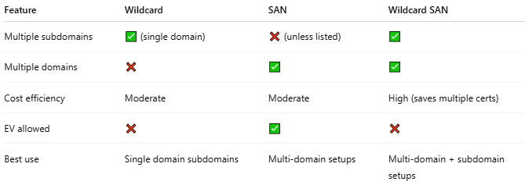
Feature | Wildcard | SAN | Wildcard SAN
Multiple subdomains | ✅ (single domain) | ❌ (unless listed) | ✅
Multiple domains | ❌ | ✅ | ✅
Cost efficiency | Moderate | Moderate | High (saves multiple certs)
EV allowed | ❌ | ✅ | ❌
Best use | Single domain subdomains | Multi-domain setups | Multi-domain + subdomain setups

One-line summary
# Source: AI Source: Provided by: [Data Path: Persons Table -> ID Column: 1, Name_En Column: Motasem Essam] -> From: [ChatGPT] on [1/18/2026]
A Wildcard SAN certificate secures multiple domains and all their first-level subdomains in a single certificate, making it ideal for large, multi-domain environments.

